Bash Scripting-01
- Bash Scripting is very important as part of automation.
- Sanity Test- free -m, ps -ef, df, du -sk (login to server and verify every day.
- To automate all the above commands every day, we follow Bash Scripting.
- Process below:
  - Vi to update the commands for automation
  - Chmod 777 test to provide full permissions
  - ./ test
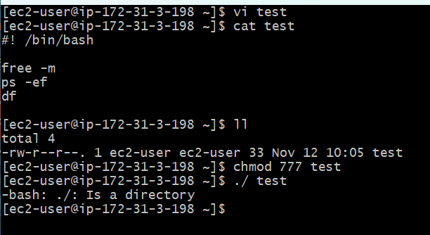

- To understand which shell are we using?
  - Echo $0
- To find all the shells present in bash?
  - Cat /etc/shells
- To find all the users using which shells?
  - Cat /etc/passwd
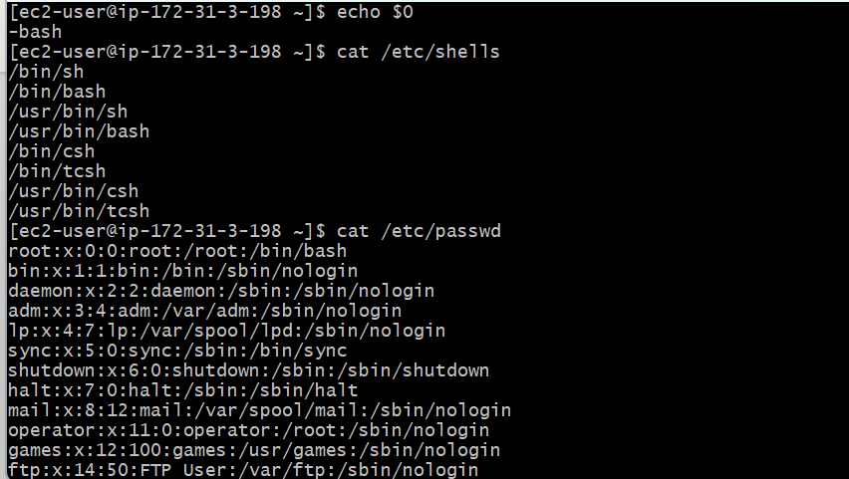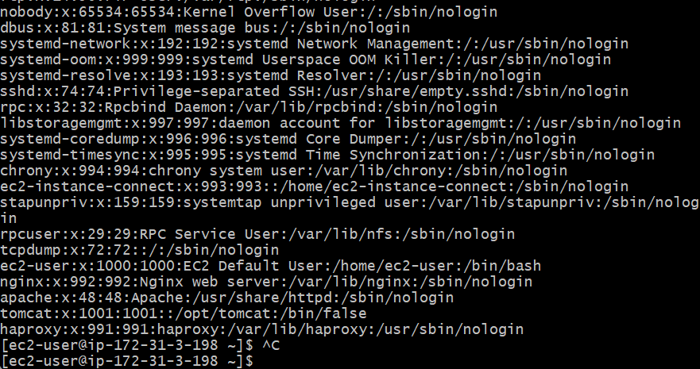
If we want to change Shells, then echo $0 to find which shell are we using currently.
Then, cat /etc/shells- to find which shells are available.
Then, simply change the shell using shell commands- sh, csh, tcsh etcc…
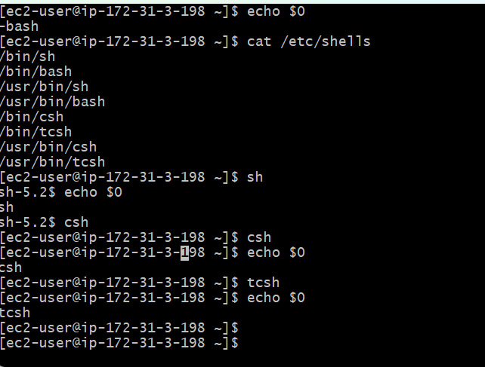
To find out absolute path and relative path, the below screenshot commands can be used.
- Pwd
- Create a directory- Mkdir -p /vicky/scripts
- Change directory- cd /vicky/scripts from root
- Ls
- Create a file- vi helloworld
- In Vi- used a command: #!bin/bash following “echo helloworld” in second line.
- Change directory- cd
- Absolute path- vicky/scripts/helloworld
- Relative path- cd /vicky/scripts
- Ls
- To execute the script: ./helloworld
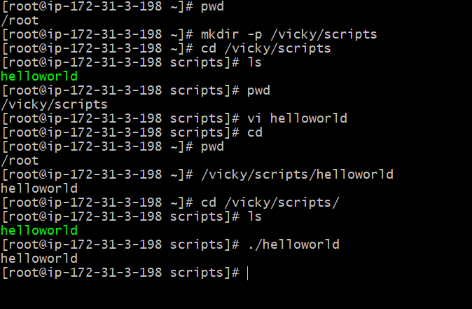
We can execute the script in 2 ways- either by “./helloworld” or by “bash helloworld”
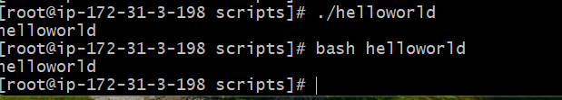

Scripting Standards:

- Always create a directory to store scripts, so we wont forget the directory where we stored.
For example:
sample to cd /vicky/scripts (relative path)
It changed from sample to /vicky/scripts. So, now I can run the scripts and execute under /vicky/scripts.
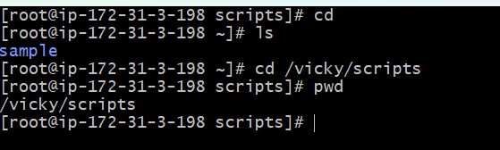
- Script Name should identify the function, so we can easily identify the script executed.
For example, my script name is helloworld
Command- cat helloworld and I can view my script edited.

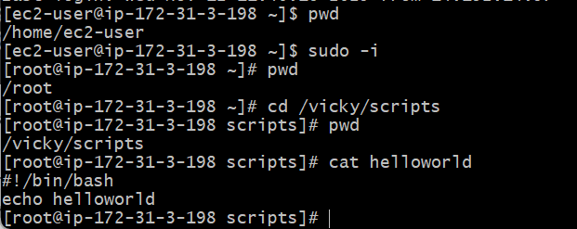

- Scripts should end with shell, so anyone who looks at the script, they will be able to identify which shell is the script run.
Renamed script name to mv helloworld helloworld.bash
.bash is the shell name.
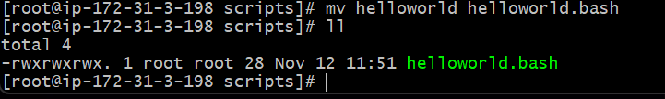

Script File Permissions:

- All scripts to be executed should have proper executable file permissions.
- If proper permissions is not provided then, the permissions denied will populate when running a script after editing in vi (test).
- Example: to change permissions: chmod 755 (test), then execute ./ (test).
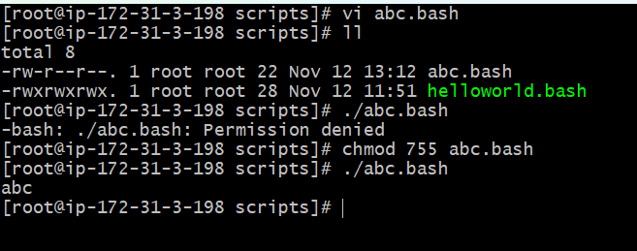

Script Format:
The format is used and will help other users to understand our script easily.
The format is as below:
- Define shell (#!/bin/bash)
  - #! – shebang characters
  - /bin/bash—shell
- Comments (#comments)
  - Always use # before entering any comments
  - #Purpose: Testing script format
  - #Date: 09/05/2025
  - #Modification: 09/05/2025
- Define variables:
  - For example variable is ‘a’ here and Container is ‘hello world’
  - a = ‘hello world’
- Commands (echo, cp, grep):
  - Echo is the command here and $a is variable here.
  - Echo $a
  - $ should always be used for any variable to be called.
- Statements (if, while, for etc.)

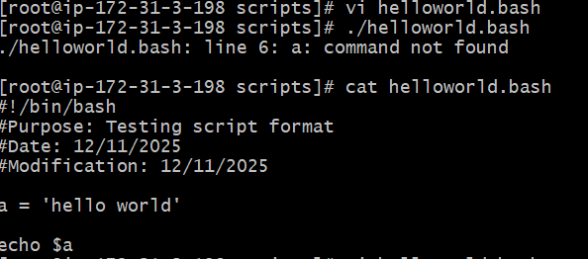
Here we changed the variable from ‘hello world’ to ‘hello DevOps’ in container.
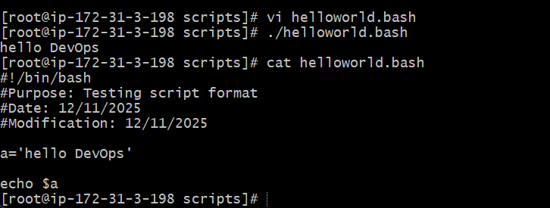

Basic Shell Script:

- Vi /helloworld.bash is the script name to be edited.
- After editing the vi--- change permissions to chmod 755 helloworld.bash
- Execute the script--- ./helloworld.bash
- Script is executed.

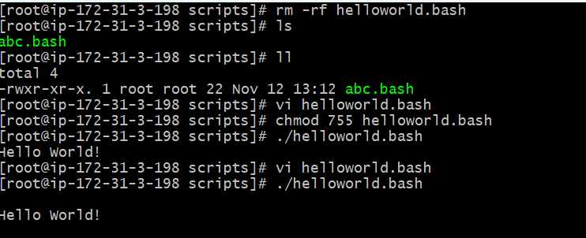

Basic Second Script
- Created a dir vicky/scripts
- Using vi editor- vi bigboss.bash:
  - Pwd
  - Ls
  - Whoami
  - Date
  - Cal
  - Touch a b c
- Executed script by using command- ./bigboss.bash --- Success.

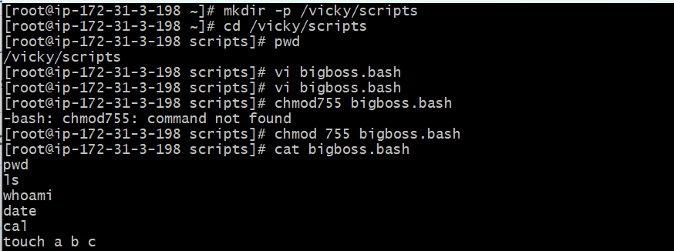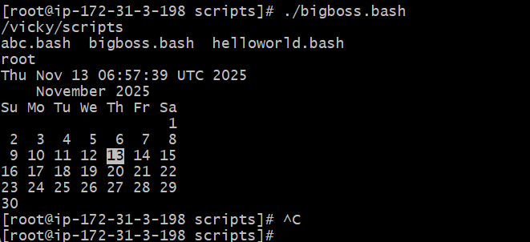

Basic Administration Tasks

- The below basic commands needs to be executed on a daily basis.
  - Top
  - Df -h
  - Free -m
  - Uptime
  - Iostat
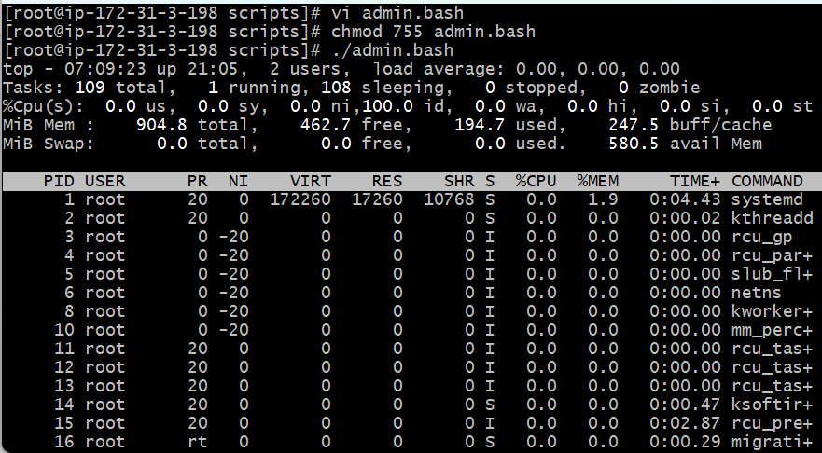
- By running the commands entered above—all the CPU utilization shows up. So we can use command – top | head -10 for the top 10 CPU utilizations.
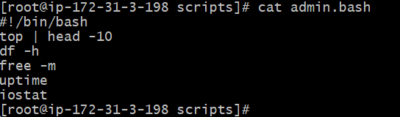
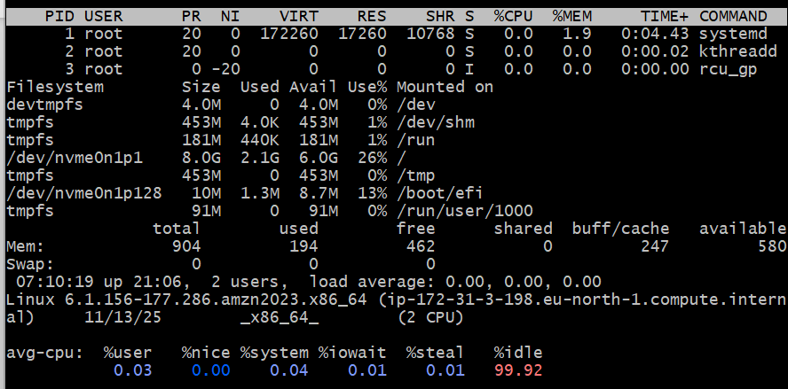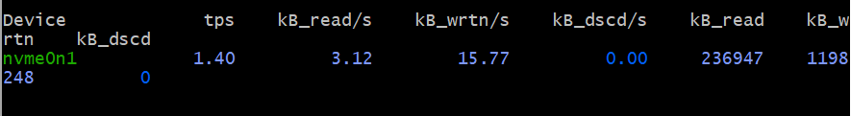

Defining variables

In programming, a variables is a value that can change, depending on conditions or a information passed to the program.
- The below executed script is of variables entered below commands using $
- Always to define variables, we should use $ symbol and to define variables- Echo.

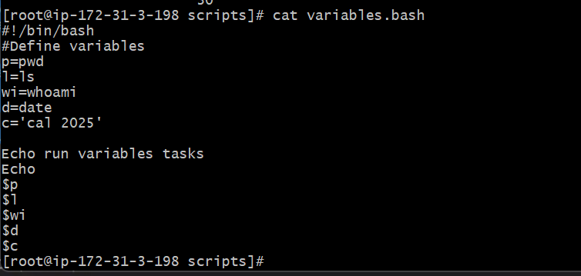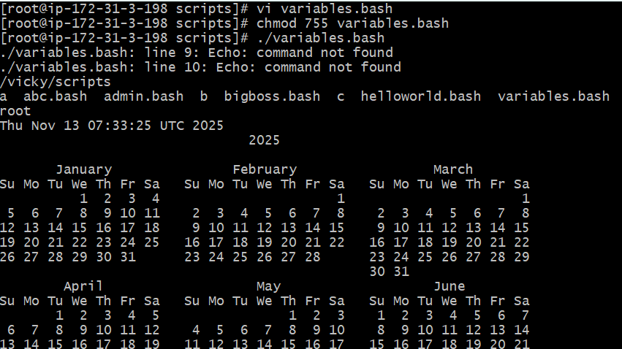

Input/output Script

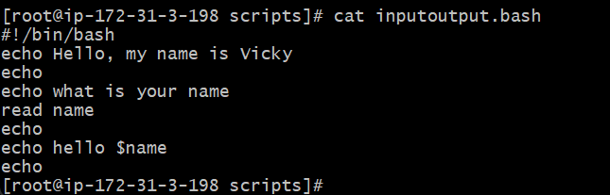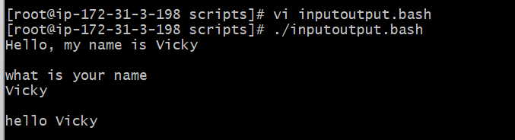

Input/Output Scripts
